Tox-Scraper MCP — System Design Blueprint v2
Two hosts · Six-layer verification · Evaluation framework · April 2026

1. Purpose
Version 1 answered a narrow question — who stands in front of the MCP server. This version answers the harder question: how do we know the report is right, and how do we measure that over time. v2 keeps the two deployment cases from v1 and adds two new pillars: a six-layer verification loop that cross-checks every paragraph in the report against a JSON ledger of extracted data, and an evaluation framework that grades each run with automated metrics, an LLM-as-judge pass, and a human rubric. The shared Python server is unchanged.
2. The Shared Core
Four MCP tools. Fourteen database harvesters. Twenty-nine review sections. Five hundred and seventy routing keywords. Every run persists three artifacts to disk: evidence.jsonl (the extracted-data JSON the user asked about), trace.jsonl (step-by-step observability), and report.docx (the deliverable). v2 introduces a fourth artifact — paragraph_citations.jsonl — that maps each paragraph in the report back to the exact ledger records it cited, with span hashes. This is the new linkage layer that makes real cross-verification possible.

3. Case 1 — Claude as Host
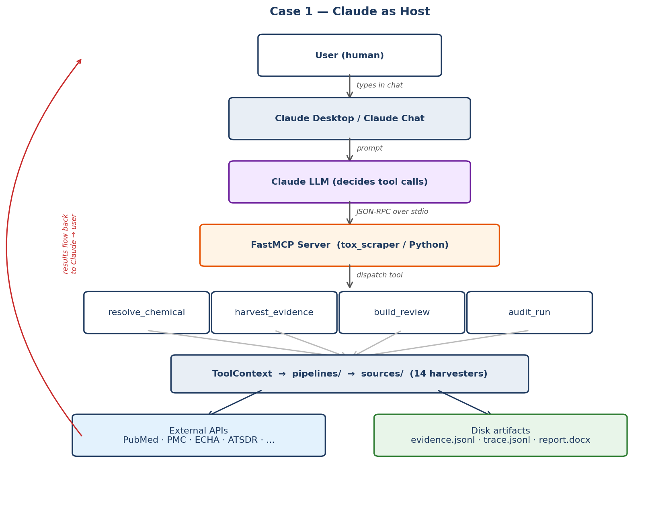
Conversational front door. Claude picks tools, handles dialogue, explains results. Adaptive but non-deterministic in the orchestration layer. Best for interactive analyst workflows and exploration.

4. Case 2 — Node.js Backend as Host
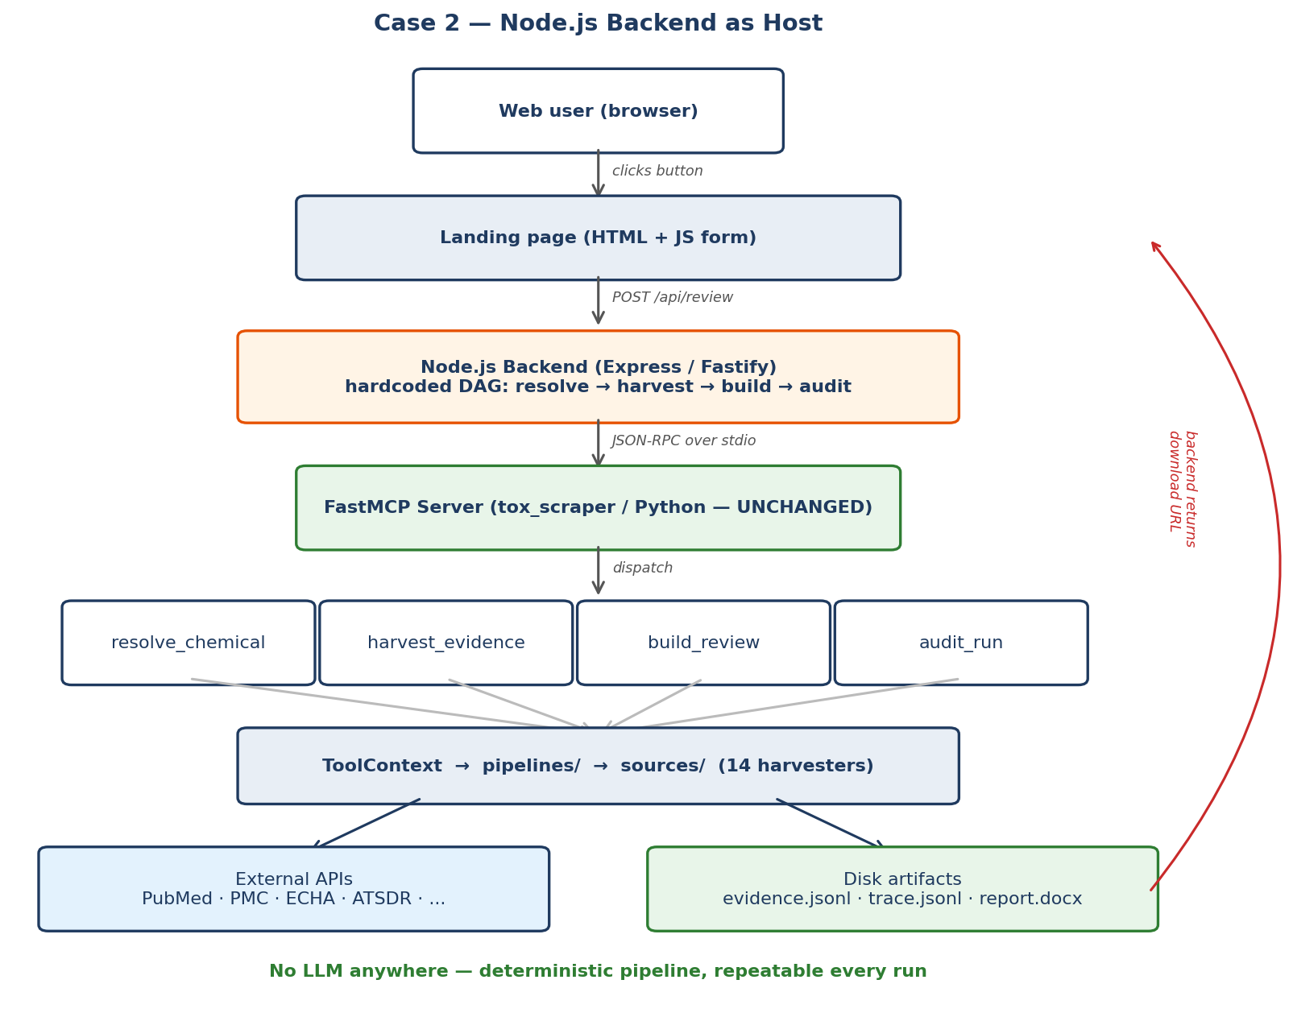
Headless front door. A Node.js service spawns the same Python MCP server and runs a fixed four-tool DAG per request. No LLM, no tokens, no adaptive behaviour. Best for production batch jobs, landing pages, and compliance-sensitive rollouts.

5. Observability & Cross-Verification (NEW)
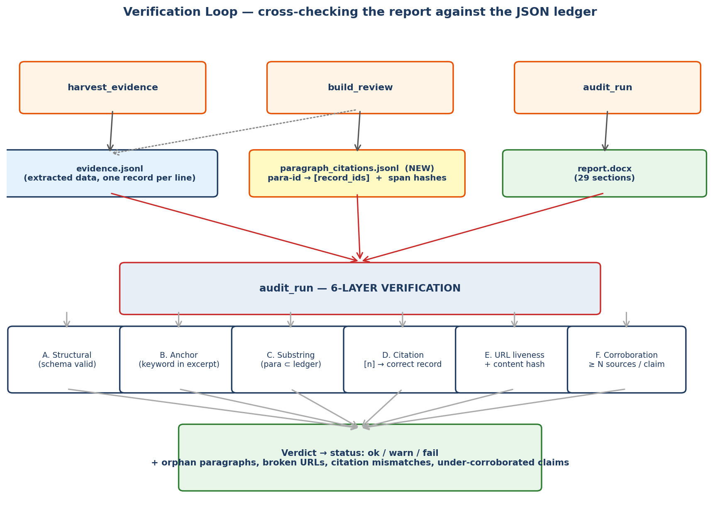
Today audit_run does one check — substring match between report paragraphs and the ledger. That catches gross hallucination but misses subtler failures: a citation that points to the wrong record, a claim backed by exactly one paper, a source URL that quietly rotted, or a paragraph whose keyword was technically present but negated in context. v2 hardens the loop into six explicit layers, all running against the JSON-serialised ledger.
The Artifacts (v2 adds paragraph_citations.jsonl)
- evidence.jsonl — one JSON line per extracted record (title, url, excerpt, keywords, section, confidence, source, hashes)
- paragraph_citations.jsonl (NEW) — one line per report paragraph: {para_id, section, text, cited_record_ids, span_hash, page_number}
- trace.jsonl — step-by-step observability JSONL (already shipped)
- report.docx — the deliverable (already shipped)
The Six Verification Layers
Layer A — Structural
Every record in evidence.jsonl is validated against the EvidenceRecord dataclass schema. Missing or mistyped fields fail at write time — nothing bad reaches disk.
Layer B — Anchor
A record exists only if a section keyword regex-matched inside the source text. The keywords_matched field names which keywords hit. Trivially auditable.
Layer C — Substring (already shipped)
Every report paragraph must appear as a substring in the ledger corpus. Orphans get flagged. This is the current audit_run behaviour, preserved.
Layer D — Citation Integrity (NEW)
Each paragraph ends with [n] citations. paragraph_citations.jsonl records which ledger record IDs those [n] values refer to. The verifier checks that record n's excerpt actually overlaps the paragraph text — not just any record somewhere in the ledger. Catches mis-numbered references that Layer C silently lets through.
Layer E — URL Liveness + Content Hash (NEW)
At harvest time we store a SHA-256 of the fetched excerpt text. audit_run probes each unique URL (with a semaphore of 6) and — for a sampled subset — re-fetches and re-hashes to detect silent content drift. Broken or rotted sources surface as warnings with their HTTP status or hash mismatch.
Layer F — Corroboration (NEW)
A claim backed by a single source is weaker than one backed by three independent sources. For each paragraph we count the number of distinct source databases in its cited records. If a high-stakes section (e.g. carcinogenicity) has paragraphs backed by only one source, the audit emits a warn — not a fail — so reviewers know where to look.
Sample paragraph_citations.jsonl
{"para_id": "ch5.carcinogenicity.p3",
"section": "carcinogenicity",
"text_preview": "Formaldehyde has been classified as carcinogenic to humans...",
"cited_record_ids": ["rec_0142", "rec_0517"],
"sources": ["WHO_INCHEM", "ECHA"],
"span_hash": "sha256:8e1a...9c",
"para_word_count": 48 }
What This Buys You
- Orphan paragraphs caught at substring level (Layer C — already shipped)
- Swapped or off-by-one citation numbers caught at citation level (Layer D)
- Link rot and silent source edits surfaced (Layer E)
- Thin-evidence sections highlighted before a human is misled (Layer F)
- Every check is deterministic, logged to audit_report.json, replayable

6. Evaluation Framework (NEW)
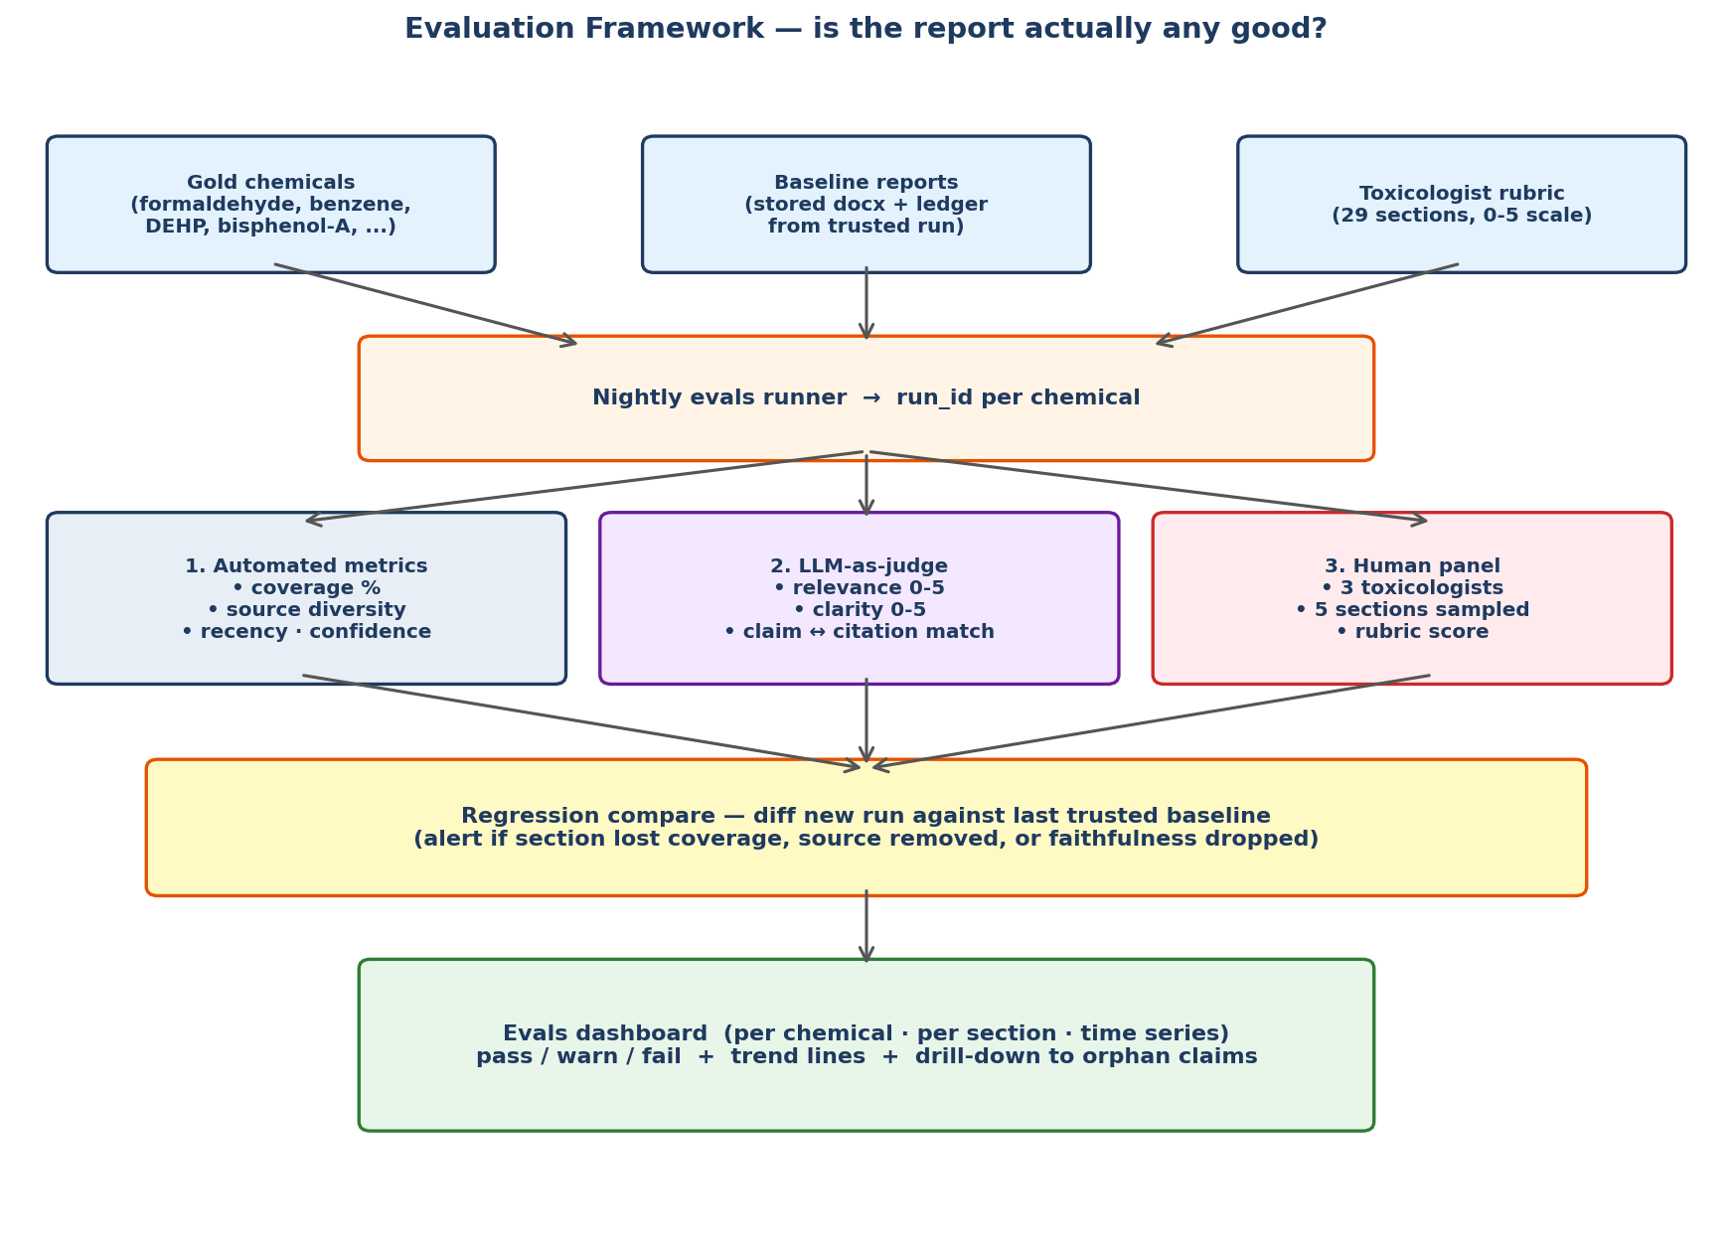
Verification tells you the report is internally consistent. Evaluation tells you the report is actually good. These are different questions. A report can be internally faithful and still miss the most important paper on a chemical. The eval framework is a nightly harness that runs the pipeline over a curated gold set, scores it three ways, and diffs against a trusted baseline.
Inputs
- Gold chemicals — ~25 well-studied substances with deep literature (formaldehyde, benzene, DEHP, bisphenol-A, styrene, lead, trichloroethylene, ...)
- Baseline reports — a trusted run per gold chemical, locked under version control, serves as the regression target
- Toxicologist rubric — 0-5 rating across 29 sections × 4 axes (coverage, accuracy, clarity, actionability)
Three Scoring Lanes
Lane 1 — Automated Metrics
- Coverage: % of 29 sections with ≥ 3 ledger records (target ≥ 90%)
- Source diversity: distinct databases per section (target ≥ 3)
- Recency: median publication year (target ≥ 2015)
- Confidence distribution: mean and p10 score (target mean ≥ 0.50)
- Faithfulness: audit_run status rate (target 100% pass)
- Citation integrity: Layer D pass rate (target 100%)
- Orphan-record rate: ledger records never cited in report (track, not gate)
Lane 2 — LLM-as-Judge
A second LLM (not the one orchestrating the pipeline) rates each paragraph on relevance and clarity (0-5 scales) and performs a claim-to-citation match check: reads the paragraph, reads the cited record's excerpt, answers "does the excerpt support the claim?" with a boolean. Cheap, fast, reproducible with a fixed seed.
Lane 3 — Human Panel
Three toxicologists each score five randomly sampled sections per chemical using the rubric. Inter-rater agreement is tracked (Cohen's kappa); when it drops the rubric gets refined. Human review is the slowest lane but the only ground truth we have for "is this section actually useful to a professional."
Regression & Dashboard
Every nightly run is diffed against the stored baseline for that chemical. If a section lost coverage, a source stopped contributing, faithfulness dropped, or the LLM-judge score fell by more than one standard deviation, the run is flagged and a diff is attached. The dashboard shows per-chemical trend lines over weeks plus drill-down to the specific paragraphs that regressed.
What "Pass" Means
- Faithfulness 100% (audit layers A-D all pass)
- Coverage ≥ 90% of sections with ≥ 3 records
- Source diversity ≥ 3 in every high-stakes section
- LLM-judge mean ≥ 4.0/5.0 on relevance + claim-support
- Human-panel mean ≥ 4.0/5.0 across the sampled sections
- No regressions vs baseline beyond tolerance band

7. Extended Case Comparison
Dimension | Case 1 — Claude Host | Case 2 — Node.js Host
Front door | Claude Desktop / Chat | Web landing page
Orchestrator | Claude LLM (adaptive) | Node.js backend (fixed DAG)
Determinism | Soft | Hard
LLM cost | Per session | None (unless LLM-judge used)
Scientific output | Identical .docx + ledger | Identical .docx + ledger
Verification loop | 6 layers — same | 6 layers — same
Evals harness | Runs server-side | Runs server-side
Suitable for batch | Awkward | Trivial
Suitable for Q&A | Yes | No (separate chat UI needed)
Compliance audit trail | Trace + ledger + citations | Trace + ledger + citations
Cross-verification freshness | On demand | On demand + nightly evals
8. Rollout Plan
Week 1 — Verification v2
- Emit paragraph_citations.jsonl from build_review (new writer)
- Add Layer D (citation integrity) to audit_run
- Add content hash to every EvidenceRecord at harvest time
Week 2 — Verification hardening
- Add Layer E (URL liveness + hash re-check) with async semaphore
- Add Layer F (per-paragraph corroboration count)
- Extend audit_report.json schema + regenerate ARCHITECTURE.md
Week 3 — Evals scaffolding
- Freeze gold-chemical list + baseline ledgers under version control
- Implement Lane 1 automated metrics
- Wire nightly runner + diff against baseline
Week 4 — LLM-judge + dashboard
- Implement Lane 2 LLM-as-judge scorer (fixed seed, separate model)
- Ship minimal Plotly/Streamlit dashboard (or Node landing-page dashboard tab)
- Recruit toxicologist panel for Lane 3, ramp rubric over the following month
9. Why This Matters
Before v2 we had a system that could produce a report and a weak check that paragraphs came from somewhere. After v2 we have a system that produces a report, proves each sentence traces back to a specific, hashed, URL-verifiable source, flags under-corroborated claims, and tells us with three independent measures whether the output is actually good for a working toxicologist. The cost is modest — one new JSONL artifact, four new audit layers, and a nightly harness — and the payoff is a system we can defend in a regulatory audit.

